PROCESS DESIGN DOCUMENT
(Activity diagram, sequence diagram)
- Process Name: Electronic Device Helpdesk Support System (Bug Reporting Telecom Support System)
- Process Description and Details
- Overview: This process illustrates the complete end-to-end operational workflow of the Bug Reporting & Telecom Support System across all 6 authorized departments (Admin, Dispatch & Order Management Dept, Call Center Staff, Technical Support Team, Back End Mail Team, and Accounts Dept), synchronized with the 5 functional modules and 15 Use Cases specified in Form 02A.
Step 1 (Role-Based Authentication — Module 3.1 / UC 1): System users from the 6 departments input their Username, Password, and Department Role. The system validates credentials, creates an active user session, and redirects the user to their role-specific dashboard.
Step 2 (Order, Dispatch & Warranty Registration — Module 3.2 / UC 2, 3, 4, 5): When a customer places an order for telecom/electronic products, the Dispatch & Order Management Department creates/updates the customer profile (UC 4), logs the order details or imports Excel invoices (UC 2), generates a unique Dispatch Number specific to that order (UC 3), and stores product-specific warranty terms and durations (UC 5).
Step 3 (Customer Inquiry & Record Lookup — Module 3.3 & 3.5 / UC 6, 7, 13): When delivery arrears or product faults occur, customers report concerns via hotline calls to Call Center Staff (UC 6) or via email to helpdesk@tele-comsupport.com handled by the Back End Mail Team (UC 7). Staff search and verify customer records using the Order Number or Dispatch Number (UC 13).
Step 4 (History Review & Fault Description Entry — Module 3.3 & 3.5 / UC 12, 14): Once the customer record is retrieved, the system displays product warranty details and the chronological history of all complaints lodged till date (UC 14). Staff enter new fault descriptions or append additional notes to existing records (UC 12).
Step 5 (Automatic Sequential Complaint ID Generation — Module 3.3 / UC 8): Immediately upon submitting a new complaint from either Call Center or Help Desk Mail, the system triggers the «include» sub-routine (UC 8) to automatically generate a unique, sequential Complaint Number (e.g., CMP-00001, CMP-00002) with initial status 'Pending' and routes the ticket to the Technical Support queue.
Step 6 (Technical Queue Review & Warranty Verification — Module 3.4 / UC 9): The Back End Technical Support Team views the complete list of complaints logged till date (UC 9), selects a ticket, reviews prior fault history, and verifies whether the product is within the active warranty period and whether a valid warranty card is presented as proof.
Step 7 (Service Charge Calculation — Module 3.4 / UC 11): If the product is within the warranty period and a valid warranty card is presented, repair service is provided free of charge (0 VND). Otherwise, if the product is Out of Warranty or missing the warranty card, the system invokes the «extend» process (UC 11) to calculate service charges (Component Replacement Cost + Labor Fee) and records the bill for the Accounts Department.
Step 8 (Status Update & Strict Non-Deletion Rule — Module 3.4 / UC 10): The Technical Support Team updates the complaint status (In Progress / Under Repair -> Serviced / Resolved -> Closed) based on the repair provided (UC 10). To ensure audit integrity, the system strictly prohibits deleting any complaint record—records can only be updated.
Step 9 (Multi-Key Tracking & Admin Performance Monitoring — Module 3.5 / UC 13, 14, 15): Authorized personnel can directly access any record by Order Number, Dispatch Number, or Complaint Number (UC 13), while the Administrator monitors complaint frequencies, staff resolution times, and service efficiency via interactive charts and Excel exports (UC 15).

3.Process Modeling (Activity Diagrams, sequence diagram by Functional Module)
3.1. Authentication & Role Management Process (Module 3.1 — UC #1: Login)
Describes how the system authenticates credentials for the 6 department roles and redirects authorized users to their respective dashboards.

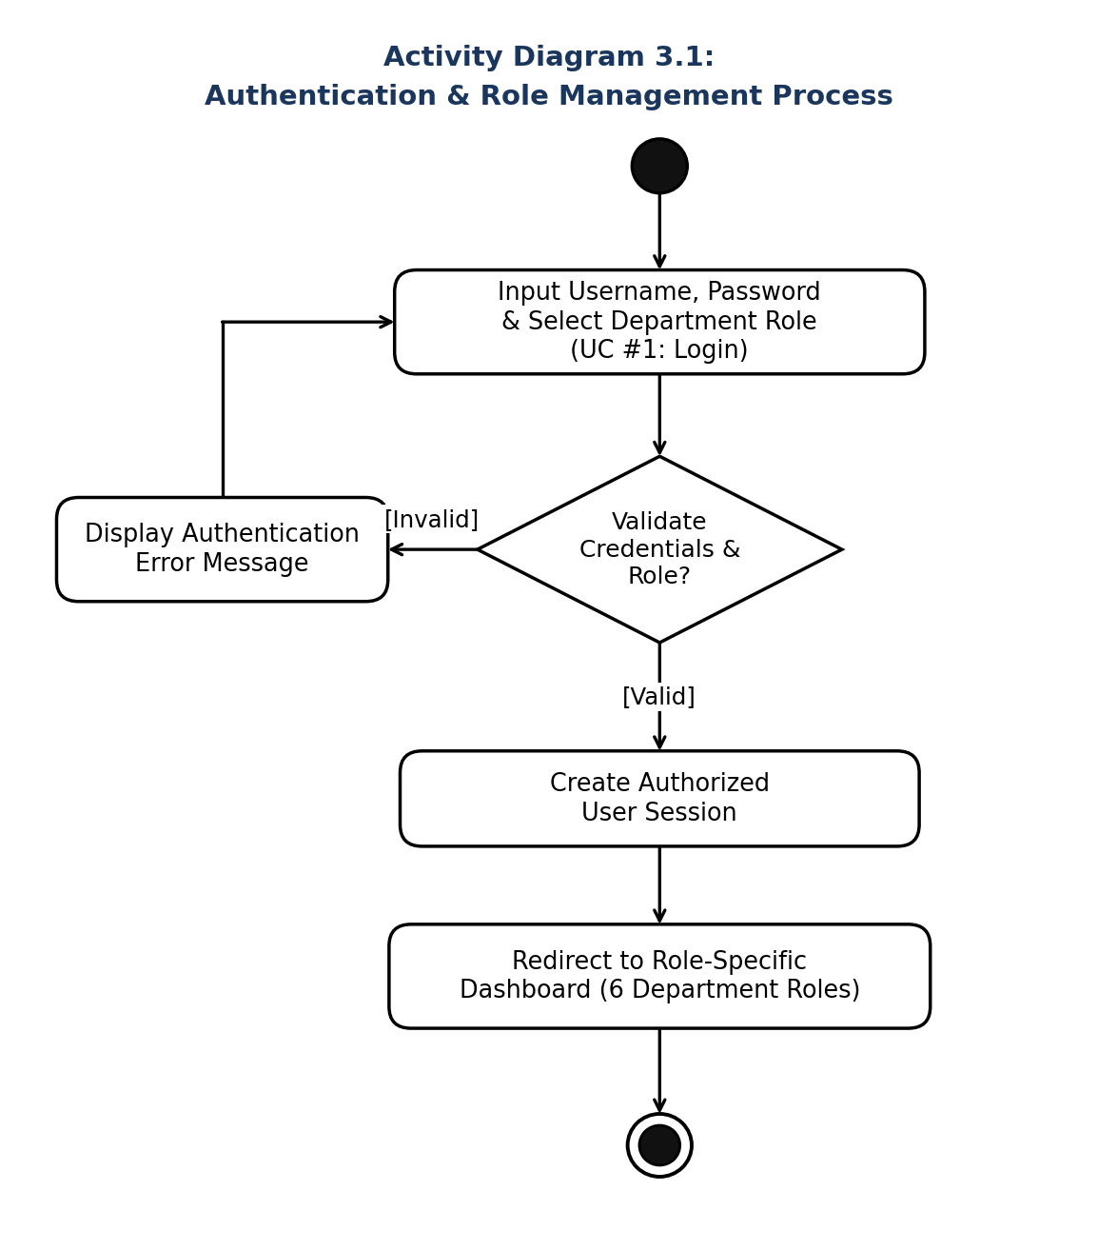

3.2. Order, Dispatch, Customer & Warranty Management Process (Module 3.2 — UC #2, #3, #4, #5)
Describes how the Dispatch & Order Management Department manages customer profiles, logs orders, generates unique Dispatch Numbers, and registers warranty terms.
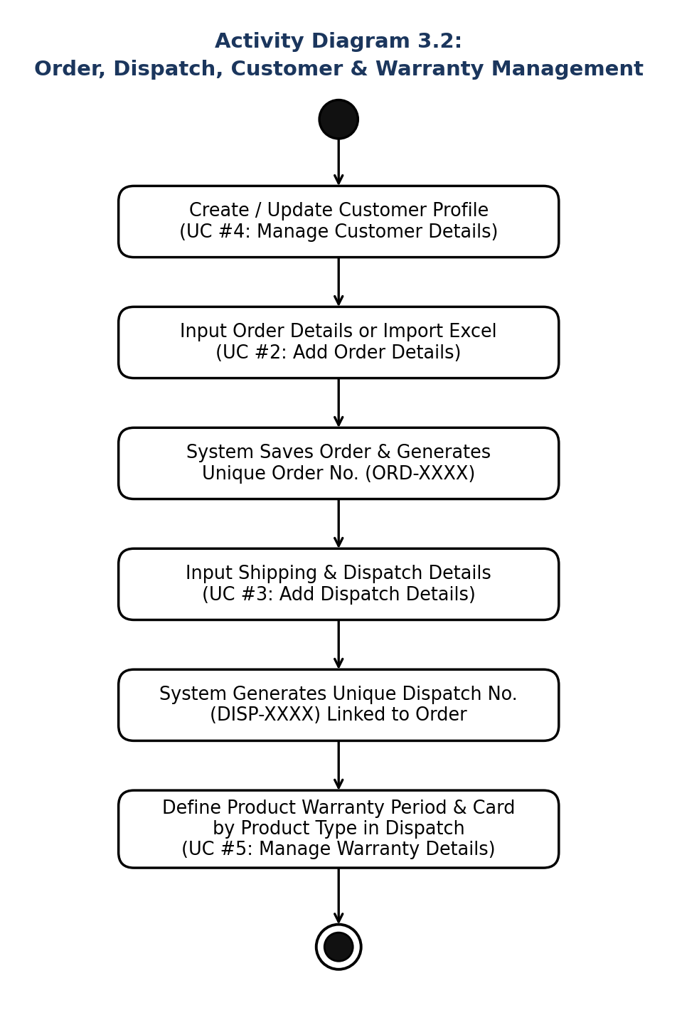
3.3. Complaint Logging & Auto-ID Generation Process (Module 3.3 — UC #6, #7, #8, #12, #14)
Describes how Call Center Staff and the Back End Mail Team look up customer orders/dispatches, log or update complaints, and trigger automatic sequential Complaint ID generation.
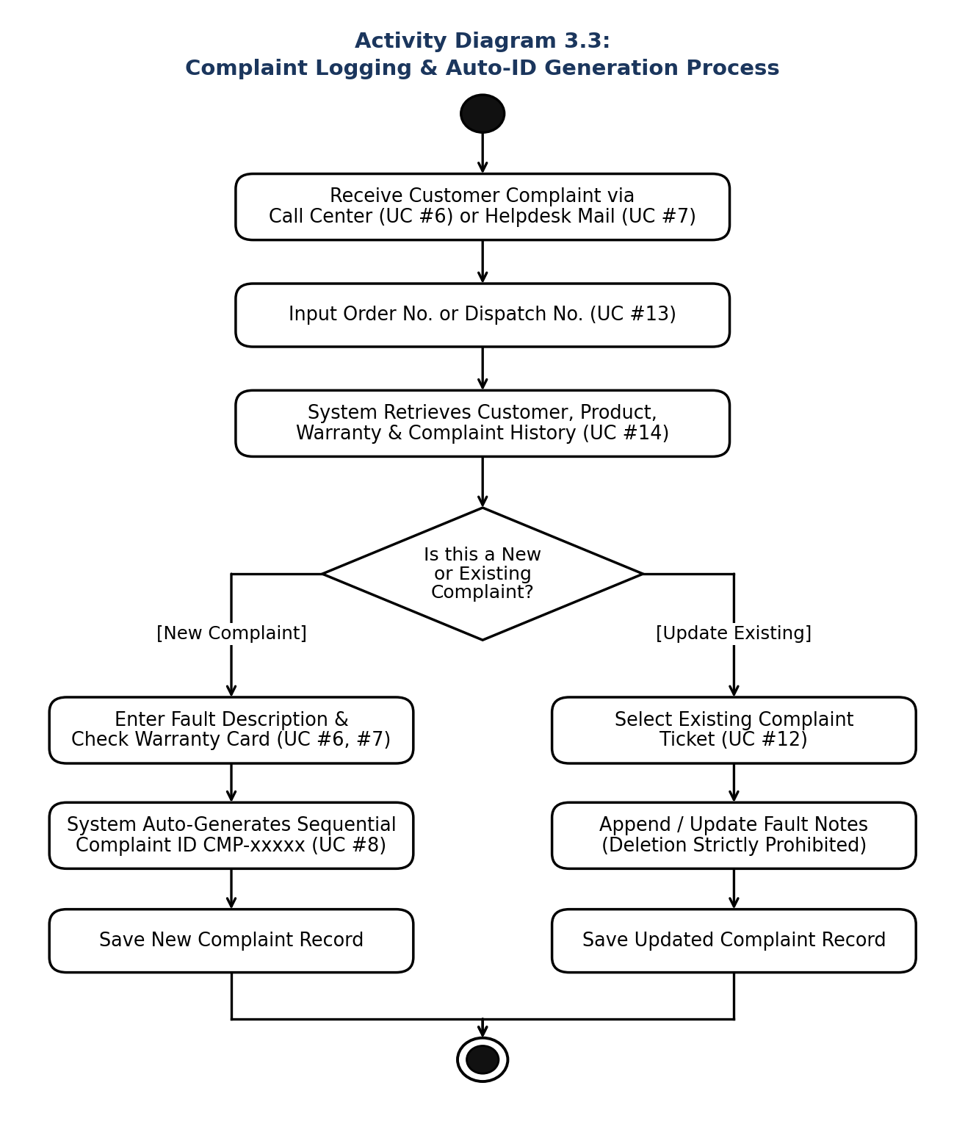

3.4. Technical Support & Service Charge Processing (Module 3.4 — UC #9, #10, #11)
Describes how the Technical Support Team reviews the complaint queue, verifies warranty eligibility and warranty card proof, calculates out-of-warranty charges for Accounts Dept, and updates resolution status.
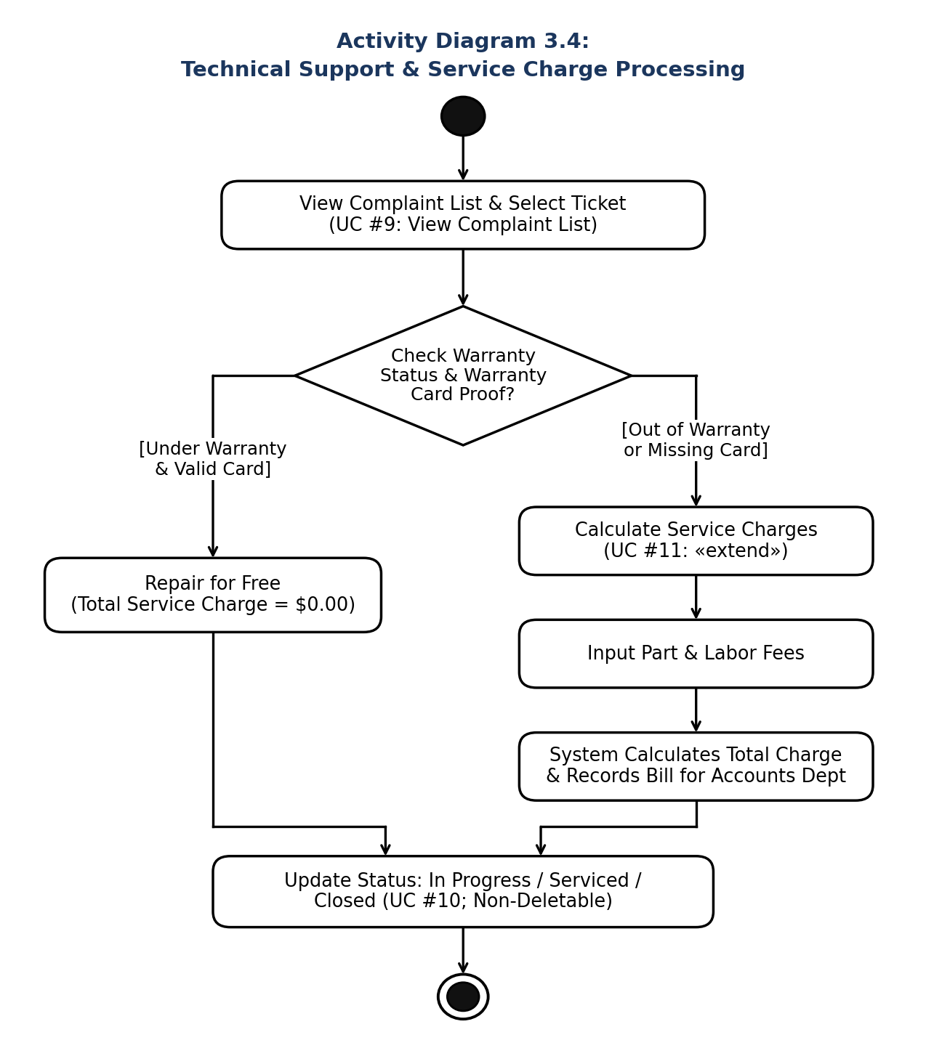

3.5. Tracking & Service Performance Monitoring Process (Module 3.5 — UC #13, #14, #15)
Describes how authorized staff track records by Order/Dispatch/Complaint No. and how the Admin monitors complaint frequency and resolution time metrics.


